Задание 1

Написать на языке Gherkin три тест-кейса для тестирования страницы (примеры написания кейсов на языке Gherkin есть в лекциях, например, Automation_5)

Кейсы должны быть простыми и НЕ входить в smoke

(Это могут быть или Scenario или Scenario Outline, если речь идет о cucumber)

<https://secure1.inmotionhosting.com/index/login>

https://www.inmotionhosting.com/

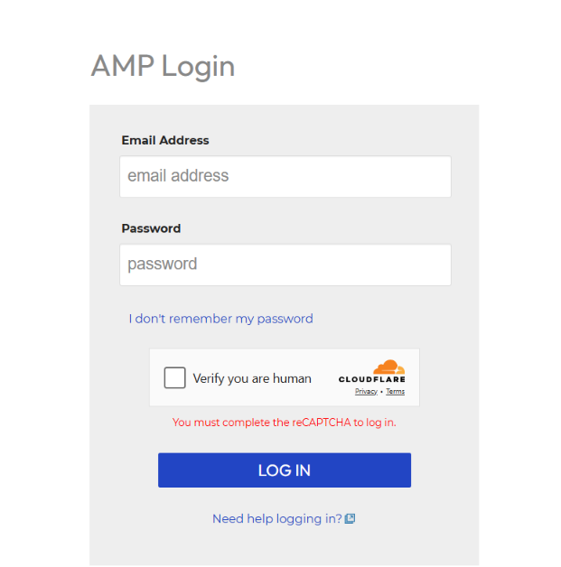

**001: Verify error message for empty login fields**  
  
Given I am on the login page

And I navigate to the login page  
When I leave the username field empty  
And I leave the password field empty  
And I click the "Login" button  
Then I should see an error message "Please enter your username and password."  
  
  
**002: Verify password visibility toggle**  
  
Given I am on the home page  
And I navigate to the login page  
And I enter "valid Username" in the username field  
And I enter "valid Password" in the password field  
When I click the "Show Password" icon  
Then the password should be visible in plain text  
When I click the "Hide Password" icon  
Then the password should be masked  
  
  
**003: Verify "Forgot Password" link functionality**  
  
Given I am on the home page  
And I navigate to the login page  
When I click the "Forgot Password?" link  
Then I should be redirected to the password recovery page  
And I should see a field to enter my registered email address